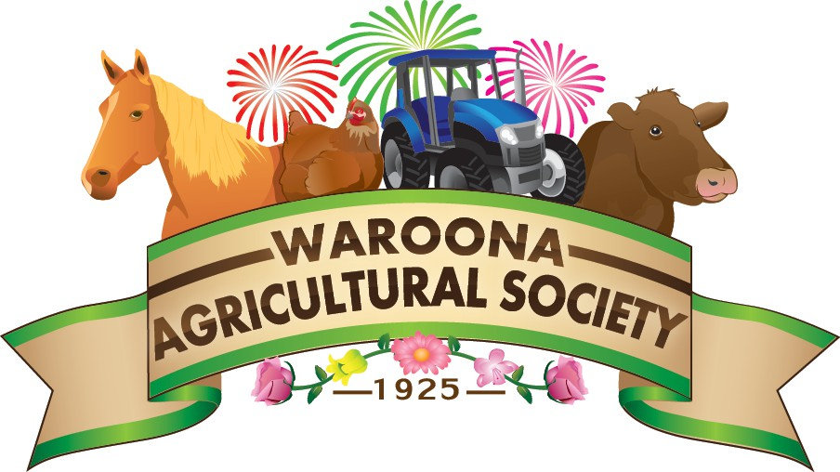
WAROONA AGRICULTURAL SOCIETY INC
Waroona Show

DISCLAIMER STATEMENT

NOTE: A SEPARATE DISCLAIMER STATEMENT IS REQUIRED FOR EACH PERSON.

Before signing this Disclaimer, refer to the Section Conditions in the Society’s Horse Program.

Exhibitor Name ……………………………………………………… Exhibit Name………….……………………………….

ADULT EXHIBITORS, RIDERS, DRIVERS, PASSENGERS, GROOMS, ATTENDANTS and ANY OTHER PARTICIPANTS 18 YEARS OF AGE and OVER

I acknowledge and agree as a condition of participating at the Waroona Agricultural Show that neither Waroona Agricultural Society, its directors, officers, employees, members and agents, participants, officials, volunteers, medical personnel, any persons, promoters, sponsors, providers of equipment, advertisers, nor Owners or Lessees of premises used to conduct the EVENT(S) shall be under any liability whatsoever for either the death of or for any injury, loss or damage which may be sustained or any claim, demand or costs arising therefrom and incurred by myself or any rider, driver, passenger, attendant or any other participant for whom I am responsible, as a result of participation in or being present at the EVENT(S).

I acknowledge that equestrian activities are dangerous and that accidents causing death, injury, disability and property damage, can, and do occur.

By signing hereunder, I confirm I have read and understood the contents of this Disclaimer together with the Society’s Section Conditions, General Regulation 17 (available on request or www.waroonashow.com.au ‘ENTRY’ link) by which I agree to abide.

Name (Print)………………………………………………………… Signature ………………………………………… Date: / /

EXHIBITORS, RIDERS, DRIVERS, PASSENGERS, GROOMS, ATTENDANTS PARTICIPANTS

UNDER 18 YEARS OF AGE

For participants of minority age (under age 18) this is to certify that I, as a Parent / Guardian with legal responsibility for this person, acknowledge, understand and accept all of the above and consent and agree to my minor child’s involvement or participation in horse sport activities.
Parent / Guardian Name (Print)………………………………………Signature…………………………………………… Date: / /
PARENTAL PERMISSION
for your child’s photograph to be used in promotional media solely for the
Waroona Show

Signature Childs Age on Show Day

